INGRESO 2024

INGLÉS



**DAYS OF THE WEEK AND MONTHS OF THE YEAR**

* **Can you colour the days in yellow and the months in red?**

|  |  |  |  |  |
| --- | --- | --- | --- | --- |
| Sunday | July | April | Saturday | January |
| October | August | Thursday | June | Tuesday |
| Friday | December | May | Wednesday | March |
| September | Monday | February | November |  |

* **Now can you write the days of the week in the correct order?**

What day is it today? __________________________________________

What day is it tomorrow? __________________________________________

What day was it yesterday? __________________________________________

* **Can you write the months of the year in the correct order?**

|  |  |
| --- | --- |
| 1._____________________  3._____________________  5._____________________  7._____________________  9._____________________  11_____________________ | 2.____________________  4.____________________  6.____________________  8.____________________  10.___________________  12.___________________ |

NUMBERS

* Spell the numbers.

60 = …………………………………………. 45 = ………………………………………

23 = ………………………………………… 82 = ………………………………………

56 = ………………………………………… 71 = ………………………………………

38 = …………………………………………… 94 = …………………………………….

* Write the numbers.

forty-seven =………………. fifty-one = …………….

sixty-nine =…………………… thirty-four = ………….

ninety-three = ……………… twenty-six =……………

seventy-eight = ……………. eighteen = …………….

**PERSONAL PRONOUNS**

**Complete with the correct pronoun**

1. (Clara and I) ………………… are at home right now.
2. (Susan) ………………. is a secretary.
3. (Matt) …………… is 47 years old.
4. (Stephen and Brenda) …………… are lawyers.
5. (the cat) …………. is on the roof.
6. Where are ………. from? ………….. am from Spain.
7. (Peter, Elena and I) …………… are friends.
8. (my father) …………. is Robert Dawson.
9. (my pencil) …………. Is under the table.
10. (Ramón, Sam and Tom) ………….. work in the hospital.

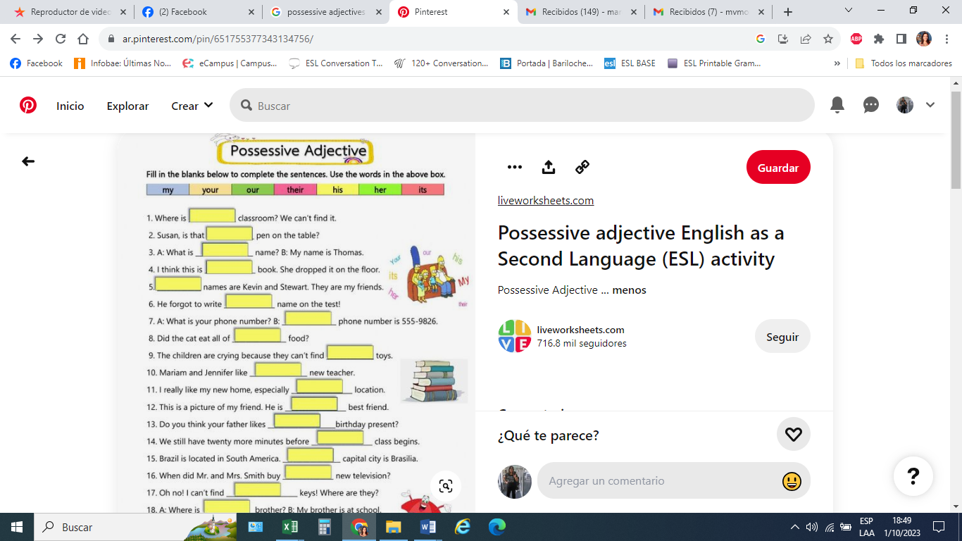

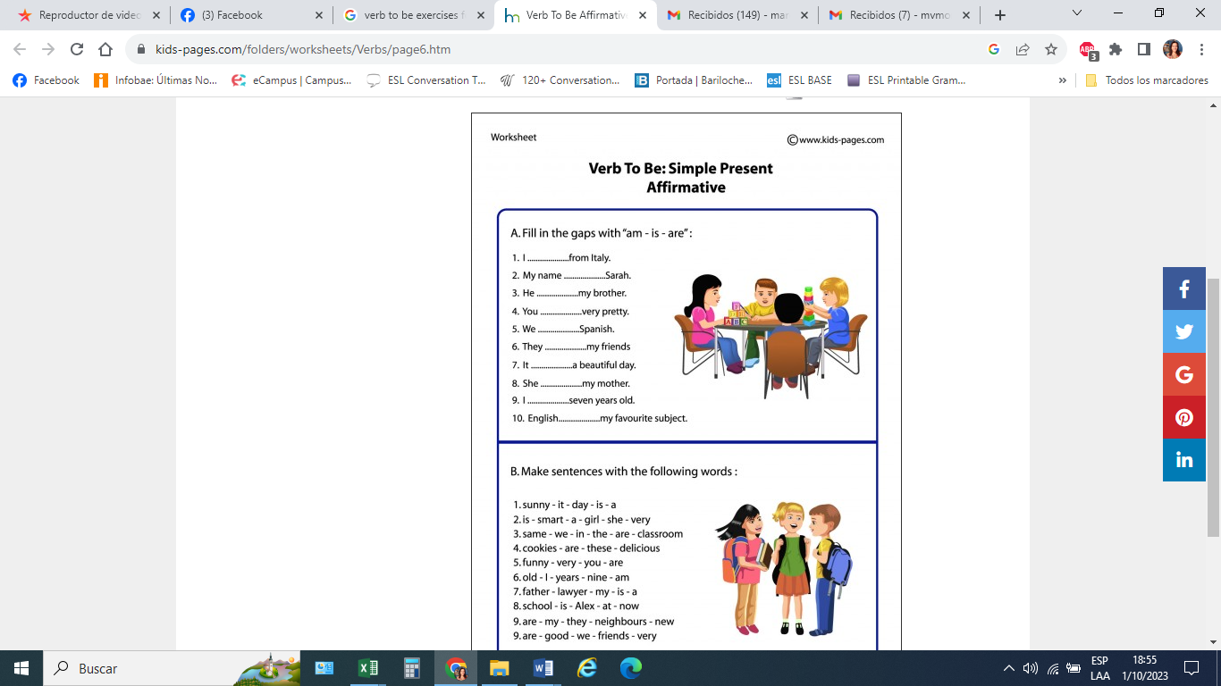

1. _______________________________________________________________
2. _______________________________________________________________
3. _______________________________________________________________
4. _______________________________________________________________
5. _______________________________________________________________
6. _______________________________________________________________
7. _______________________________________________________________
8. _______________________________________________________________
9. _______________________________________________________________
10. _______________________________________________________________